2.10 Comments
This approach is more meaningful than the previous one and so is more effective. The
extra power given must be paid for by additional search time in the knowledge bases. A warning must be given here: that is - to generate unambiguous English knowledge base is a complex task and must be left until later in the course. The problems of handling pronouns are difficult.
For example:
Rani walked up to the salesperson: she asked where the toy department was.
Rani walked up to the salesperson: she asked her if she needed any help.
Whereas in the original text the linkage of ‘she’ to ‘Rani’ is easy, linkage of ‘she’ in each of the above sentences to Rani and to the salesperson requires additional knowledge about the context via the people in a shop.

Method 3
2.11 Data Structures

World model contains knowledge about objects, actions and situations that are described
in the input text. This structure is used to create integrated text from input text. The diagram
shows how the system’s knowledge of shopping might be represented and stored. This
information is known as a script and in this case is a shopping script. (See figure 1.1 next page )

1.8.2.12 Algorithm
Convert the question to a structured form using both the knowledge contained in Method
2 and the World model, generating even more possible structures, since even more knowledge is
being used. Sometimes filters are introduced to prune the possible answers.
To answer a question, the scheme followed is: Convert the question to a structured form as before but use the world model to resolve any ambiguities that may occur. The structured form is matched against the text and the requested segments of the question are returned.

2.13 Example
Both questions 1 and 2 generate answers, as in the previous program. Question 3 can now
be answered. The shopping script is instantiated and from the last sentence the path through step
14 is the one used to form the representation. ‘M’ is bound to the red coat-got home. ‘Rani buys a red coat’ comes from step 10 and the integrated text generates that she bought a red coat.
2.14 Comments
This program is more powerful than both the previous programs because it has more
knowledge. Thus, like the last game program it is exploiting AI techniques. However, we are not
yet in a position to handle any English question. The major omission is that of a general
reasoning mechanism known as inference to be used when the required answer is not explicitly
given in the input text. But this approach can handle, with some modifications, questions of the
following form with the answer—Saturday morning Rani went shopping. Her brother tried to
call her but she did not answer.
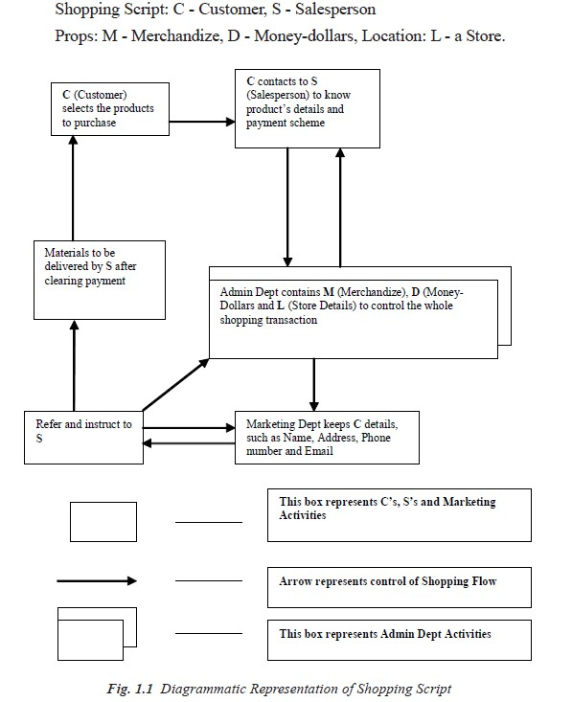
Question: Why couldn’t Rani’s brother reach her?
Because she was not in.

This answer is derived because we have supplied an additional fact that a person cannot be in two places at once. This patch is not sufficiently general so as to work in all cases and does not provide the type of solution we are really looking for.

12

LEVEL OF THE AI MODEL
‘What is our goal in trying to produce programs that do the intelligent things that people do?’

Are we trying to produce programs that do the tasks the same way that people do?
OR
Are we trying to produce programs that simply do the tasks the easiest way that is
possible?
Programs in the first class attempt to solve problems that a computer can easily solve and do not usually use AI techniques. AI techniques usually include a search, as no direct method is available, the use of knowledge about the objects involved in the problem area and abstraction on which allows an element of pruning to occur, and to enable a solution to be found in real time; otherwise, the data could explode in size. Examples of these trivial problems in the first class, which are now of interest only to psychologists are EPAM (Elementary Perceiver and
Memorizer) which memorized garbage syllables.
The second class of problems attempts to solve problems that are non-trivial for a computer and use AI techniques. We wish to model human performance on these:
1. To test psychological theories of human performance. Ex. PARRY [Colby, 1975] - a
program to simulate the conversational behavior of a paranoid person.
2. To enable computers to understand human reasoning - for example, programs that
answer questions based upon newspaper articles indicating human behavior.
3. To enable people to understand computer reasoning. Some people are reluctant to accept
computer results unless they understand the mechanisms involved in arriving at the
results.
4. To exploit the knowledge gained by people who are best at gathering information. This
persuaded the earlier workers to simulate human behavior in the SB part of AISB
simulated behavior. Examples of this type of approach led to GPS (General Problem
Solver).
Questions for Practice:
1. What is intelligence? How do we measure it? Are these measurements useful?
2. When the temperature falls and the thermostat turns the heater on, does it act because it
believes the room to be too cold? Does it feel cold? What sorts of things can have beliefs
or feelings? Is this related to the idea of consciousness?
3. Some people believe that the relationship between your mind (a non-physical thing) and
your brain (the physical thing inside your skull) is exactly like the relationship between a
computational process (a non-physical thing) and a physical computer. Do you agree?
4. How good are machines at playing chess? If a machine can consistently beat all the best
human chess players, does this prove that the machine is intelligent?
5. What is AI Technique? Explain Tic-Tac-Toe Problem using AI Technique.

13

PROBLEMS, PROBLEM SPACES AND SEARCH

To solve the problem of building a system you should take the following steps:
1. Define the problem accurately including detailed specifications and what constitutes a suitable solution.
2. Scrutinize the problem carefully, for some features may have a central affect on the chosen method of solution.
3. Segregate and represent the background knowledge needed in the solution of the
problem.
4. Choose the best solving techniques for the problem to solve a solution.
Problem solving is a process of generating solutions from observed data.
• a ‘problem’ is characterized by a set of goals,
• a set of objects, and
• a set of operations.
These could be ill-defined and may evolve during problem solving.
• A ‘problem space’ is an abstract space.
✓ A problem space encompasses all valid states that can be generated by the
application of any combination of operators on any combination of objects. ✓ The problem space may contain one or more solutions. A solution is a
combination of operations and objects that achieve the goals.
• A ‘search’ refers to the search for a solution in a problem space.
✓ Search proceeds with different types of ‘search control strategies’.
✓ The depth-first search and breadth-first search are the two common search
strategies.

2.1 AI - General Problem Solving
Problem solving has been the key area of concern for Artificial Intelligence.

Problem solving is a process of generating solutions from observed or given data. It is however not always possible to use direct methods (i.e. go directly from data to solution). Instead,
problem solving often needs to use indirect or modelbased methods.

General Problem Solver (GPS) was a computer program created in 1957 by Simon and Newell
to build a universal problem solver machine. GPS was based on Simon and Newell’s theoretical
work on logic machines. GPS in principle can solve any formalized symbolic problem, such as
theorems proof and geometric problems and chess playing. GPS solved many simple problems,
such as the Towers of Hanoi, that could be sufficiently formalized, but GPS could not solve any
real-world problems.
To build a system to solve a particular problem, we need to:
• Define the problem precisely - find input situations as well as final situations for an
acceptable solution to the problem

14

• Analyze the problem - find few important features that may have impact on the
appropriateness of various possible techniques for solving the problem
• Isolate and represent task knowledge necessary to solve the problem
• Choose the best problem-solving technique(s) and apply to the particular problem

Problem definitions
A problem is defined by its ‘elements’ and their ‘relations’. To provide a formal description of a problem, we need to do the following:
a. Define a state space that contains all the possible configurations of the relevant objects,
including some impossible ones.
b. Specify one or more states that describe possible situations, from which the problem-
solving process may start. These states are called initial states.
c. Specify one or more states that would be acceptable solution to the problem.

These states are called goal states.
Specify a set of rules that describe the actions (operators) available.

The problem can then be solved by using the rules, in combination with an appropriate control strategy, to move through the problem space until a path from an initial state to a goal state is found. This process is known as ‘search’. Thus:

• Search is fundamental to the problem-solving process.
• Search is a general mechanism that can be used when a more direct
method is not known.
• Search provides the framework into which more direct methods for
solving subparts of a problem can be embedded. A very large number of AI problems are formulated as search problems.
• Problem space

A problem space is represented by a directed graph, where nodes represent search state and paths represent the operators applied to change the state.
To simplify search algorithms, it is often convenient to logically and programmatically represent a problem space as a tree. A tree usually decreases the complexity of a search at a cost. Here, the cost is due to duplicating some nodes on the tree that were linked numerous times in the graph, e.g. node B and node D.
A tree is a graph in which any two vertices are connected by exactly one path. Alternatively, any connected graph with no cycles is a tree.

15

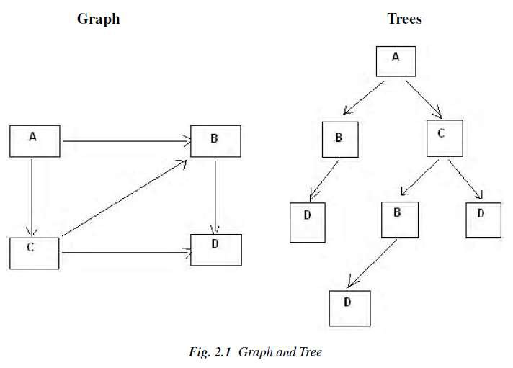

• Problem solving: The term, Problem Solving relates to analysis in AI. Problem solving may be
characterized as a systematic search through a range of possible actions to reach some predefined
goal or solution. Problem-solving methods are categorized as special purpose and general
purpose.
• A special-purpose method is tailor-made for a particular problem, often exploits very specific features of the situation in which the problem is embedded.

• A general-purpose method is applicable to a wide variety of problems. One General-purpose technique used in AI is ‘means-end analysis’: a step-bystep, or incremental, reduction of the difference between current state and final goal.

16

2.3 DEFINING PROBLEM AS A STATE SPACE SEARCH

To solve the problem of playing a game, we require the rules of the game and targets for winning as well as representing positions in the game. The opening position can be defined as the initial state and a winning position as a goal state. Moves from initial state to other states leading to the goal state follow legally. However, the rules are far too abundant in most games— especially in chess, where they exceed the number of particles in the universe. Thus, the rules cannot be
supplied accurately and computer programs cannot handle easily. The storage also presents
another problem but searching can be achieved by hashing.

The number of rules that are used must be minimized and the set can be created by expressing each rule in a form as possible. The representation of games leads to a state space representation and it is common for well-organized games with some structure. This representation allows for the formal definition of a problem that needs the movement from a set of initial positions to one of a set of target positions. It means that the solution involves using known techniques and a systematic search. This is quite a common method in Artificial Intelligence.

2.3.1 State Space Search
A state space represents a problem in terms of states and operators that change states. A state space consists of:
• A representation of the states the system can be in. For example, in a
board game, the board represents the current state of the game.
• A set of operators that can change one state into another state. In a board
game, the operators are the legal moves from any given state. Often the
operators are represented as programs that change a state representation to represent the new state.
• An initial state.
• A set of final states; some of these may be desirable, others undesirable.
This set is often represented implicitly by a program that detects terminal
states.

2.3.2 The Water Jug Problem

In this problem, we use two jugs called four and three; four holds a maximum of four gallons of
water and three a maximum of three gallons of water. How can we get two gallons of water in
the four jug?

The state space is a set of prearranged pairs giving the number of gallons of water in the pair of jugs at any time, i.e., (four, three) where four = 0, 1, 2, 3 or 4 and three = 0, 1, 2 or 3.
The start state is (0, 0) and the goal state is (2, n) where n may be any but it is limited to three holding from 0 to 3 gallons of water or empty. Three and four shows the name and numerical number shows the amount of water in jugs for solving the water jug problem. The major
production rules for solving this problem are shown below:

17

Initial condition Goal comment
1. (four, three) if four < 4 (4, three) fill four from tap
2. (four, three) if three< 3 (four, 3) fill three from tap
3. (four, three) If four > 0 (0, three) empty four into drain
4. (four, three) if three > 0 (four, 0) empty three into drain
5. (four, three) if four + three<4 (four + three, 0) empty three into
four
6. (four, three) if four + three<3 (0, four + three) empty four into
three
7. (0, three) If three > 0 (three, 0) empty three into four
8. (four, 0) if four > 0 (0, four) empty four into three
9. (0, 2) (2, 0) empty three into four
10. (2, 0) (0, 2) empty four into three
11. (four, three) if four < 4 (4, three-diff) pour diff, 4-four, into
four from three
12. (three, four) if three < 3 (four-diff, 3) pour diff, 3-three, into
three from four and a solution is
given below four three rule
(Fig. 2.2 Production Rules for the Water Jug Problem)

Gallons in Four Jug Gallons in Three Jug Rules Applied
0 0 -
0 3 2
3 0 7
3 3 2
4 2 11
0 2 3
2 0 10
(Fig. 2.3 One Solution to the Water Jug Problem)
The problem solved by using the production rules in combination with an appropriate control
strategy, moving through the problem space until a path from an initial state to a goal state is
found. In this problem solving process, search is the fundamental concept. For simple problems
it is easier to achieve this goal by hand but there will be cases where this is far too difficult.
2.4 PRODUCTION SYSTEMS

Production systems provide appropriate structures for performing and describing search processes. A production system has four basic components as enumerated below.
• A set of rules each consisting of a left side that determines the applicability of the
rule and a right side that describes the operation to be performed if the rule is
applied.
• A database of current facts established during the process of inference.

18

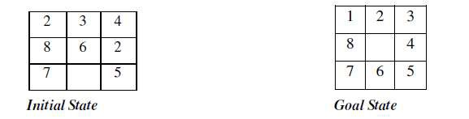
• A control strategy that specifies the order in which the rules will be compared
with facts in the database and also specifies how to resolve conflicts in selection
of several rules or selection of more facts.
• A rule firing module.
The production rules operate on the knowledge database. Each rule has a precondition—that is, either satisfied or not by the knowledge database. If the precondition is satisfied, the rule can be applied. Application of the rule changes the knowledge database. The control system chooses which applicable rule should be applied and ceases computation when a termination condition on the knowledge database is satisfied.

Example: Eight puzzle (8-Puzzle)
The 8-puzzle is a 3 × 3 array containing eight square pieces, numbered 1 through 8, and
one empty space. A piece can be moved horizontally or vertically into the empty space, in effect
exchanging the positions of the piece and the empty space. There are four possible moves, UP
(move the blank space up), DOWN, LEFT and RIGHT. The aim of the game is to make a
sequence of moves that will convert the board from the start state into the goal state:

This example can be solved by the operator sequence UP, RIGHT, UP, LEFT, DOWN.
Example: Missionaries and Cannibals

The Missionaries and Cannibals problem illustrates the use of state space search for planning under constraints:
Three missionaries and three cannibals wish to cross a river using a two person boat. If at any time the cannibals outnumber the missionaries on either side of the river, they will eat the missionaries. How can a sequence of boat trips be performed that will get everyone to the other side of the river without any missionaries being eaten?
State representation:
1. BOAT position: original (T) or final (NIL) side of the river.
2. Number of Missionaries and Cannibals on the original side of the river.
3. Start is (T 3 3); Goal is (NIL 0 0).
Operators:

19

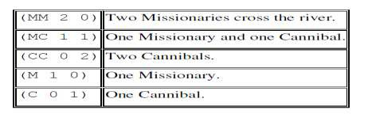
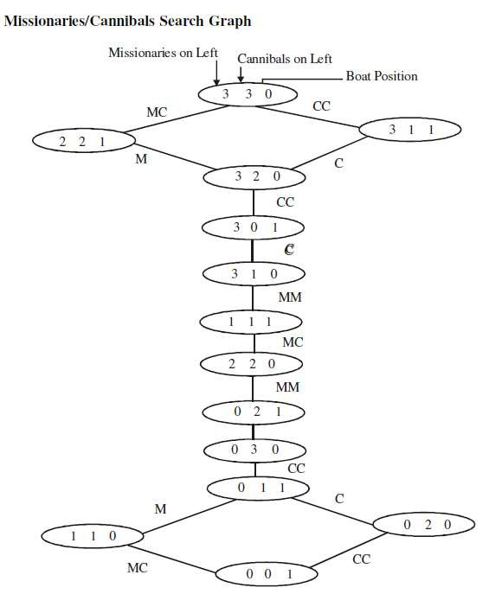

20

